Brian Dekker

Brian.dekker@hva.nl

Logic Apps

Summary

Index

Azure Logic Apps (Learning Story) 2

Creating our first simple email response logic app. 2

What is azure logic app. 2

Step by step what I did. 2

Creating a logic app that uses outlook calendar. 17

My first attempt. 17

My second attempt. 18

Attempt number 3. 18

Attempt 4 19

# Azure Logic Apps (Learning Story)

Ik wil onderzoeken hoe ik mijn eigen afspraken uit outlook kan halen, met als doel dit later te gebruiken in een PA.

Ik begin daarom met te kijken of dit met en logic app kan.

## Creating our first simple email response logic app.

My first step was to read through this Microsoft page to get an understanding of how to use logic apps with outlook.

<https://docs.microsoft.com/en-us/azure/connectors/connectors-create-api-office365-outlook>

## What is azure logic app.

Azure Logic Apps is a cloud service. Using Logic Apps defines the workflow at ease consuming a range of APIs exposed as Connectors. These Logic App connectors will perform the sequence of actions defined in the workflow whenever the trigger gets fired.

## Step by step what I did.

First I created a logic app in my azure portal.

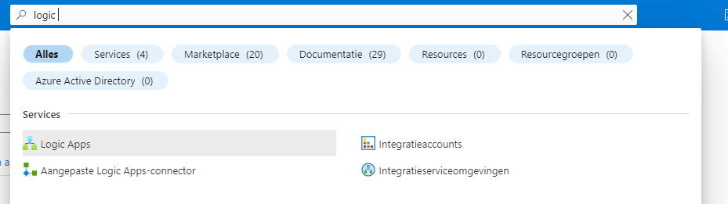

When you select the logic app u it will direct you to a new page where u can see your exsisting logic apps and create new ones.

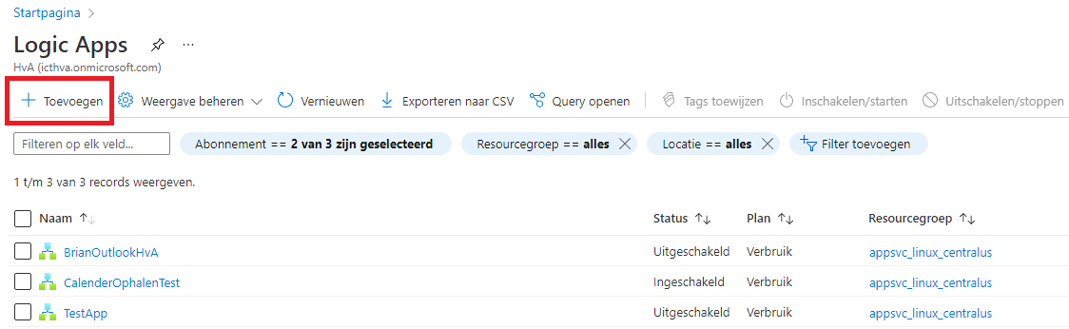

After selecting to create a new logic app a new window opens with options that need to be filled in to create a logic app. In the screenshot below u can see the default create form when I first open it apart from the plan I changed that from standard to consumption.

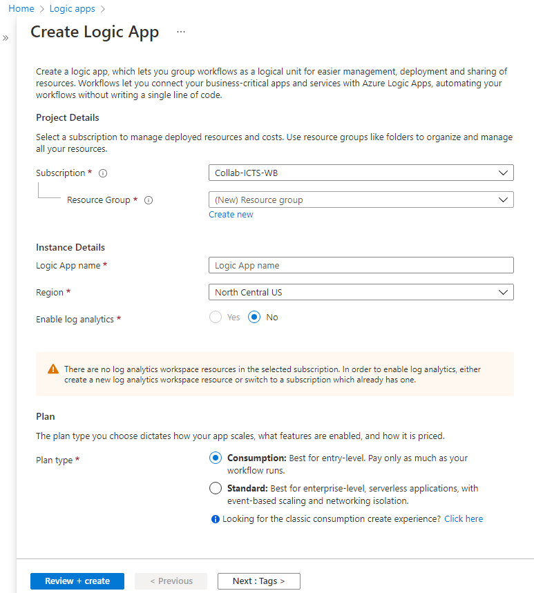

Explanation of options.

**Subscription/Recourse group:** Here you select what azure subscription you want to use and wich recourse group that is a part of that subscription.

**App name:** The name of the App does not matter in way the app will function so I suggest to pick something that is relevant to the functionality of the app.

**Region:** Region you want to host your logic app.

**Enable log analytics:** Log analytics allows you to save data

**Plan Type:**

* **Consumption :** Consumption is a per use based plan so you pay every time the logic app is triggered. The first 4000 triggers are free.
* **Standard :** Standard is a pay per hour the logic app is online based plan.

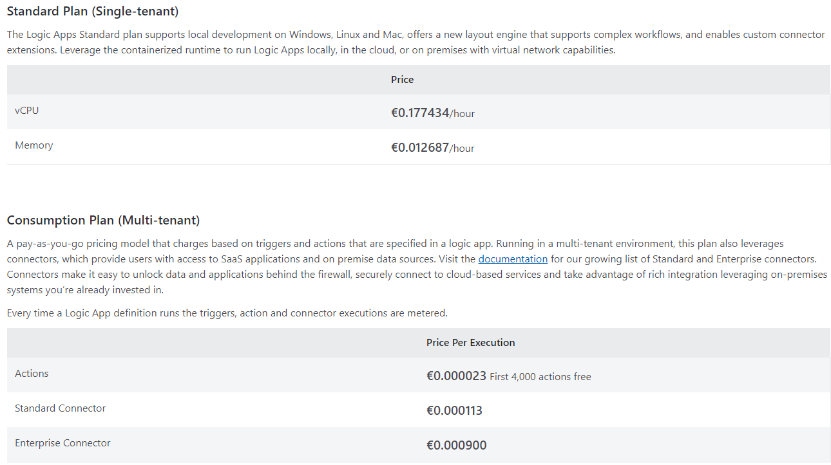

Now that we know what options we have when creating a logic app we can fill out the form. In the next screen shot you can see the filled out options I used when creating my logic apps.

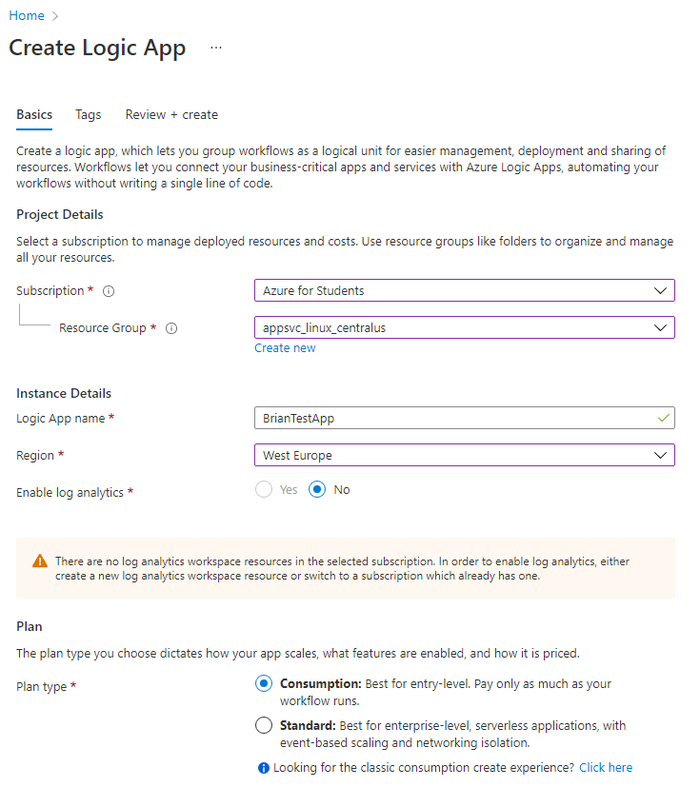

The reason I used the Azure for students subscription this time is because the HBO-ICT subscription gets a error saying it has no permission to create a logic app.

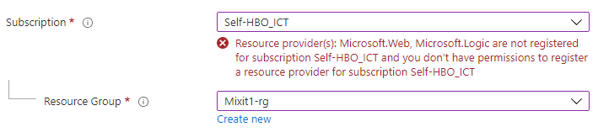

Now we can review and create our logic app.

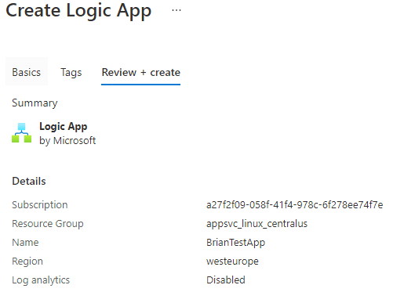

After creating our logic app it will give you the option to go to the recourse.

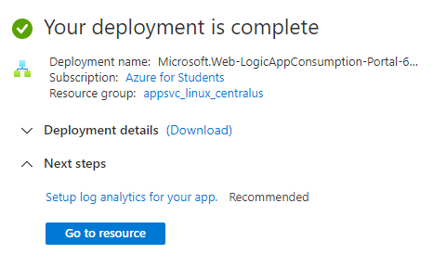

When going to the recourse you will see a small introduction video and a few common trigger option you can choose. I chose the blank logic app option

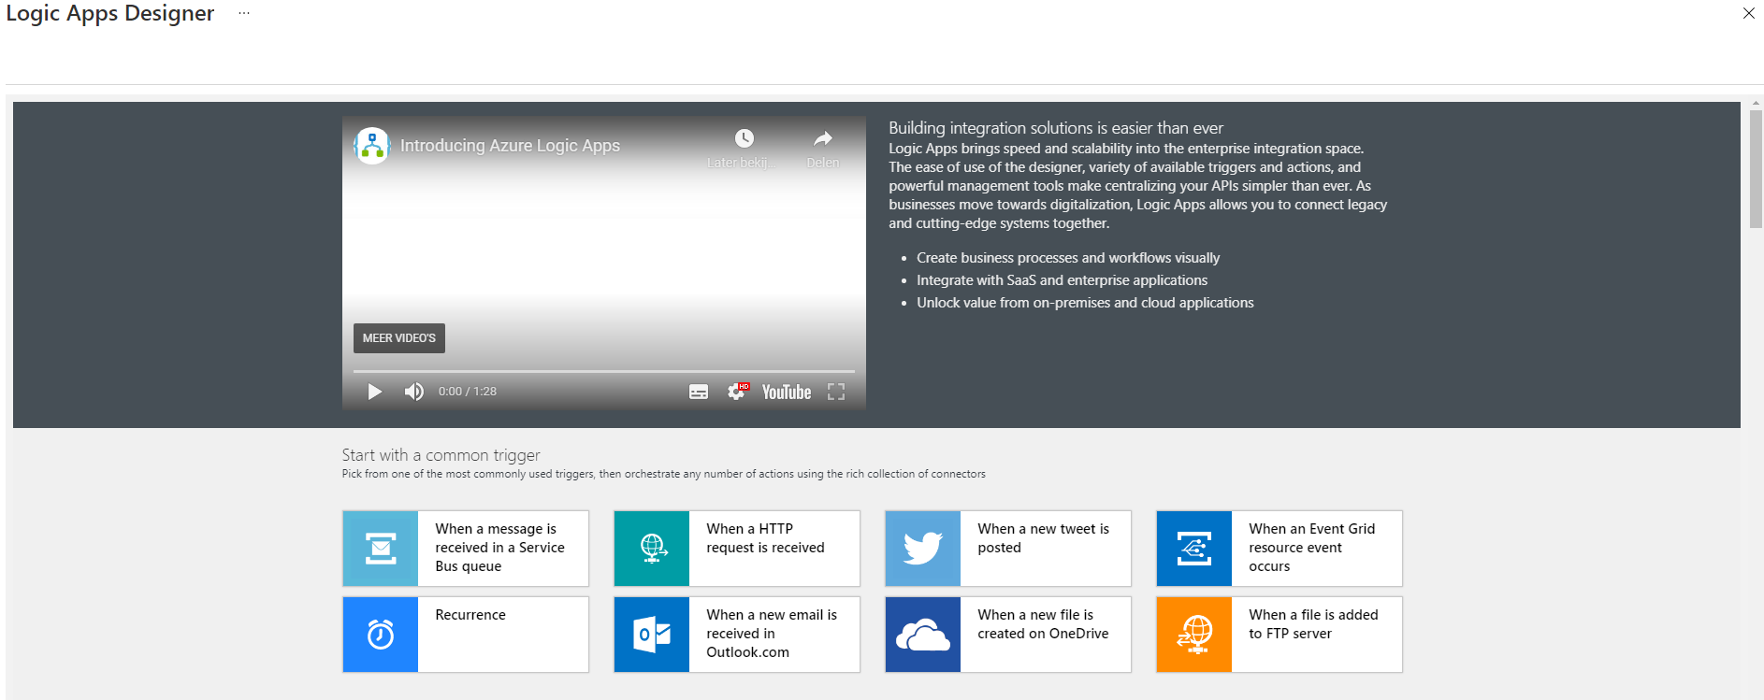

If you scroll down a little bit you can see the option to create a blank logic app I chose that one for my first logic app.

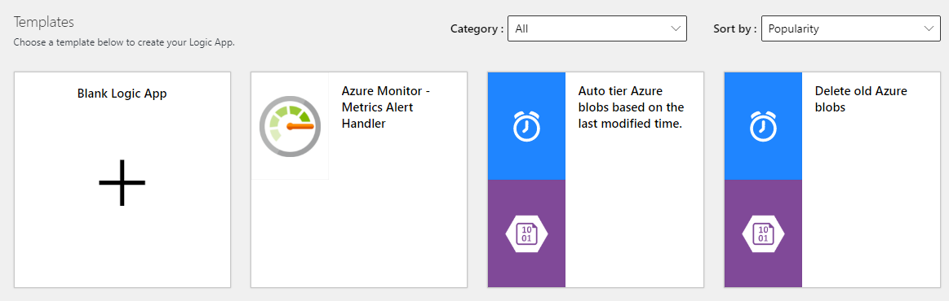

After selection the blank logic app it will open the editing screen for your logic app that is the screen where u can add triggers and action for the logic app.

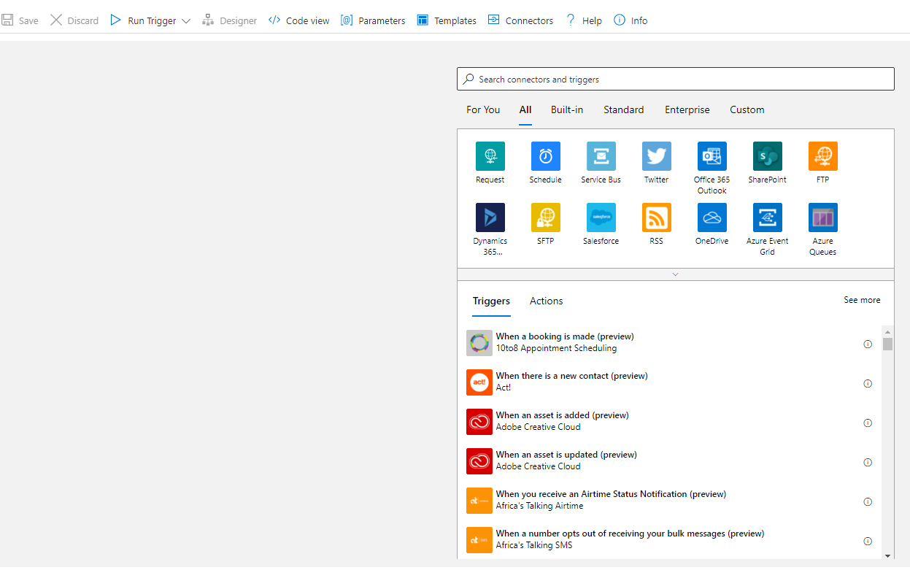

Now I want to create a logic app that uses outlook so the first thing I did was type outlook into the search bar.

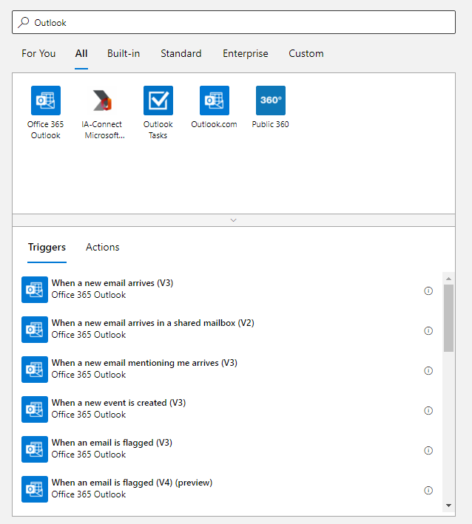

Now we can see all the triggers that can be used based on office 365 Outlook. For my first logic app I choose the top option trigger when a new email arrives (V3).

When u select that trigger it will ask you to login to a office 365 account in our case that would be our HvA account so in my case [brian.dekker@hva.nl](mailto:brian.dekker@hva.nl).

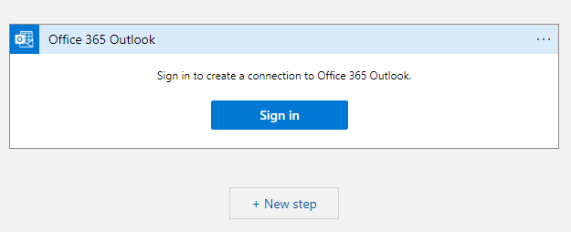

After login in you will see the option that are used in this trigger.

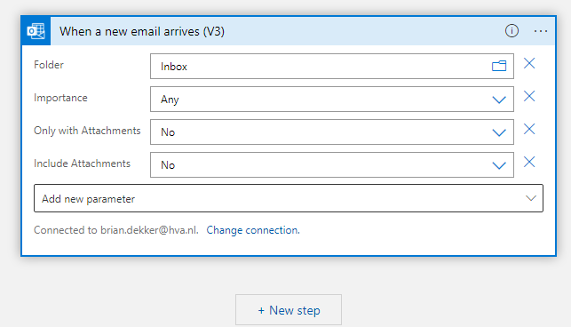

Now I kept it very simple I want to look at my inbox and when a new email arrives from my Gmail account I want to automatically respond.

In order to only trigger when the new email is from my gmail account we need to add a FROM parameter.

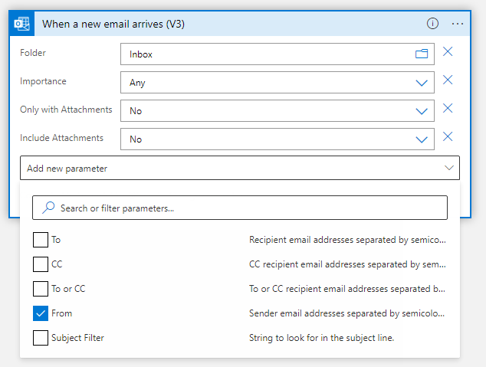

Now that we have selected that parameter it will show up in our trigger options.

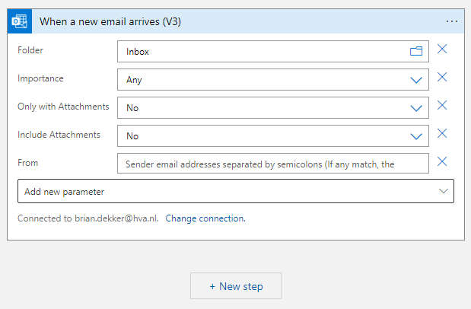

All I need to do now is add my gmail to the from option.

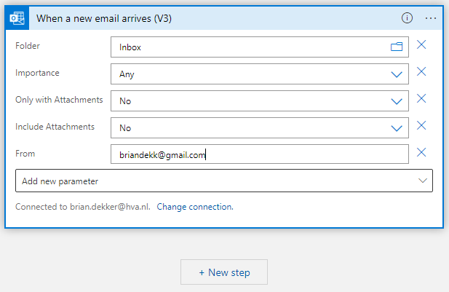

Now our trigger step is done but a trigger alone is not enough we need to tell it what to do when the trigger is executed.

When you click new step it opens a new selection menu where u can search and select what u want the app to do after it is triggered.

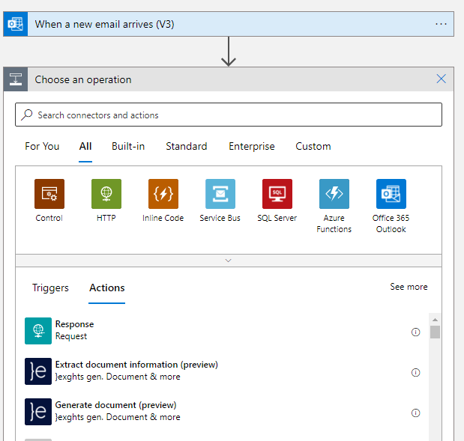

Now we want to use office 365 outlook to respond to the email automatically so once again we search for outlook and select office outlook 365.

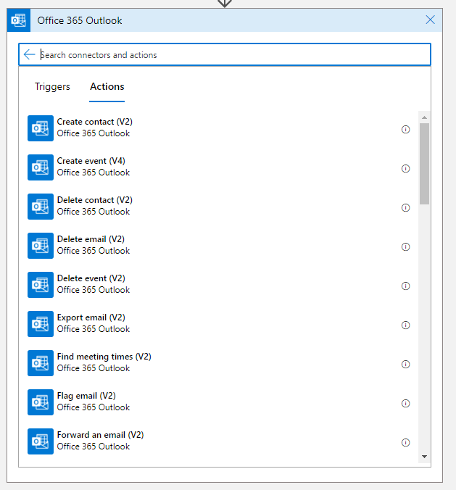

We now get a list of actions that are possible to use with outlook. The option I want is Replay to email (V3).



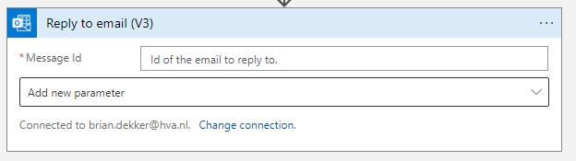

Now we get one option and that is to what email it should reply. If we click on the input box it will open a window on the side with option we are looking for the **messageId** option.

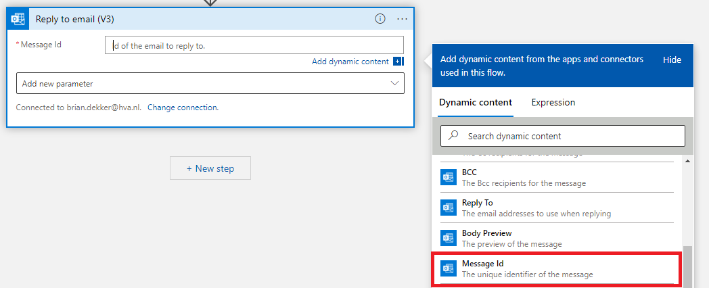

Now I also want to send something back so in the parameter menu I selected to add a body.

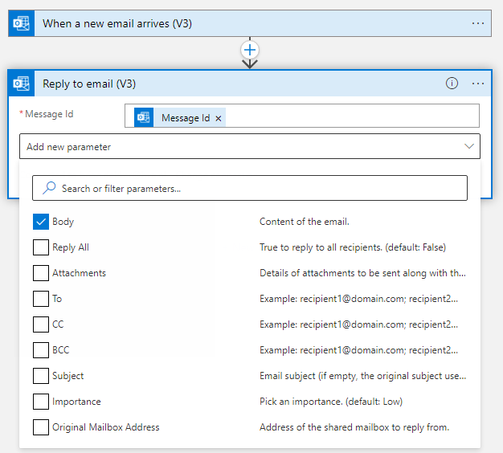

In this body you can put what ever text you want so for now I just put in THIS IS A TEST.

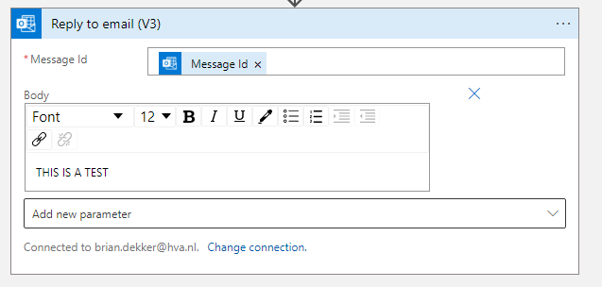

We can now click save at the top right and It should work so let’s test it.

So we will send this email to my HvA outlook account.

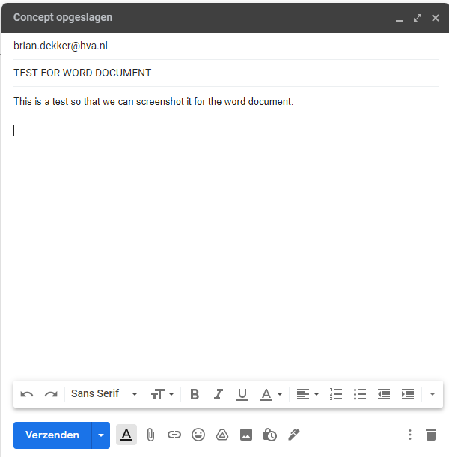

And I expect a reply within a minute.

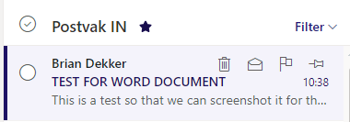

We can see the email arrived and when we open it we can see that the reply has already been sent back so it’s very fast. If you don’t see that a reply has been send back yet just wait a little bit.

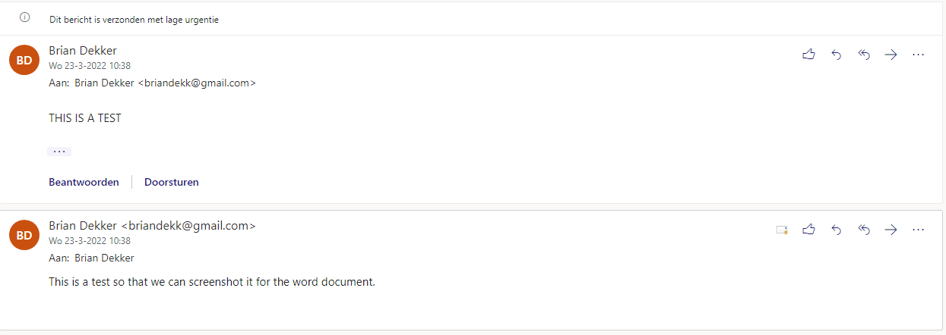

If the reply has been send then your logic app works correctly if the reply was not send that means something went wrong u can check what went wrong by going to your logic app overview and selecting the execution that has an error.

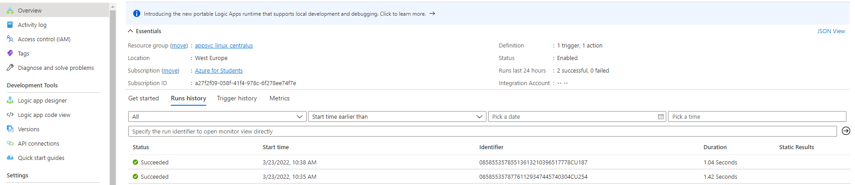

When a execution failed it should look something like this.



When you select your failed execution it will take you to your workflow and that lets you see where in the workflow the logic app failed.

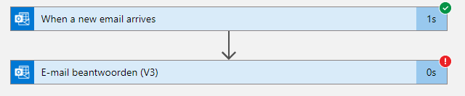

You can then open that step and see what the error message says and hopefully solve that problem.

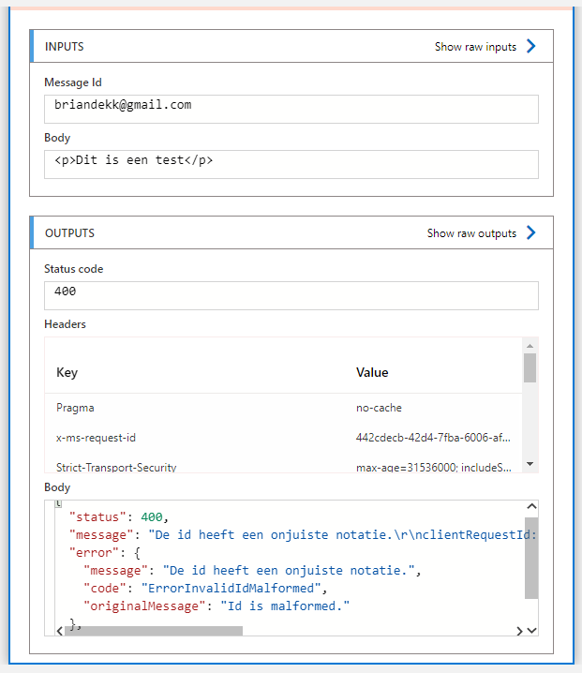

So in this case the message id was incorrect because I didn’t know what variable it expected me to use when I did it for the very first time.

## Creating a logic app that uses outlook calendar.

So now we want to create a logic app that is a more relevant to our learning story.

## My first attempt.

My first attempt was if something changes in my calendar retrieve my calendar.

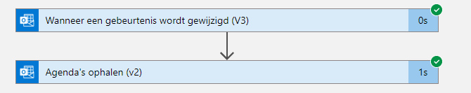

Now this works but it does not give me the output I want I lirelary gives you back the name of your calendars.

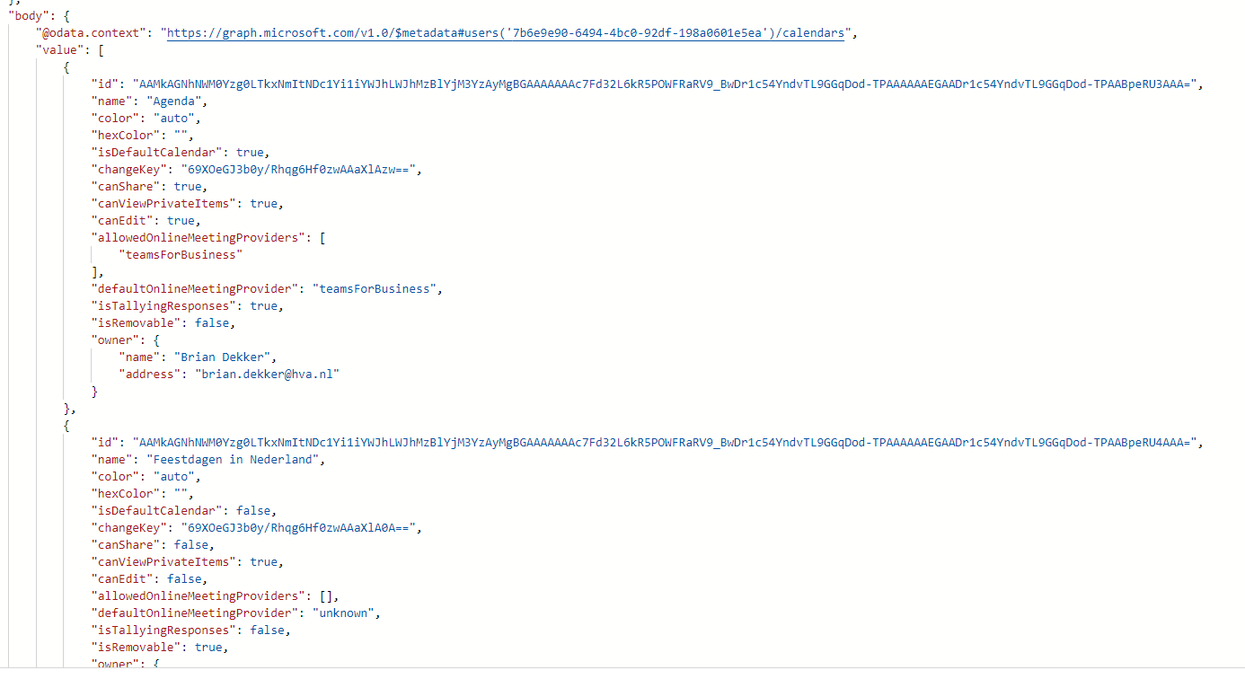OUTPUT:

So I needed something else.

## My second attempt.

My second attempt was more what I wanted as a output it actually returns me the created/edited event back.

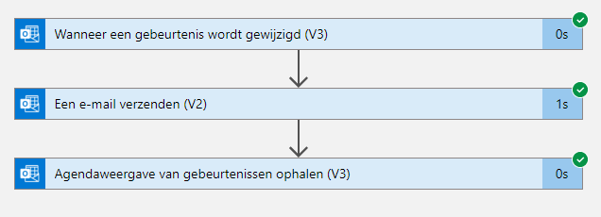

OUTPUT:

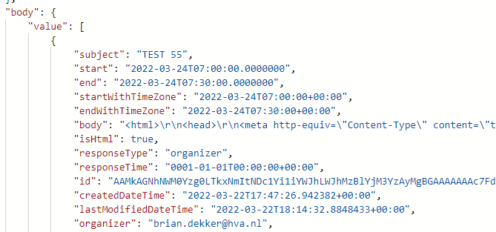

The output is a lot bigger then this but this is basically the event that I created/edited.

## Attempt number 3.

Now that I had the correct output I wanted to see if I could use it somehow unfortunately it was not as simple as I thought there is no option to use the output of a previous set in your next step or at least I have not found a way to do that yet. But I did try a couple different actions that return events on the calendar the most relevant one was Retrieve events (V4) this one when run return more then one event in the calendar when the logic app triggers this might be useful to retrieve schedules for an entire day.

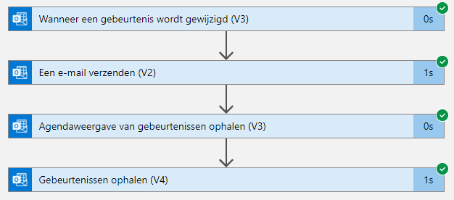

The output of this step is way to big to copy into word but its like attempt 2 but more then just the one created/edited event.

## Attempt 4

I now wanted to attempt sending the output of attempt 2 in the email I send myself kind of like a notification system.

So I have now discovered that how to use values from previous steps (Microsoft can really use some interface improvements on this front.)

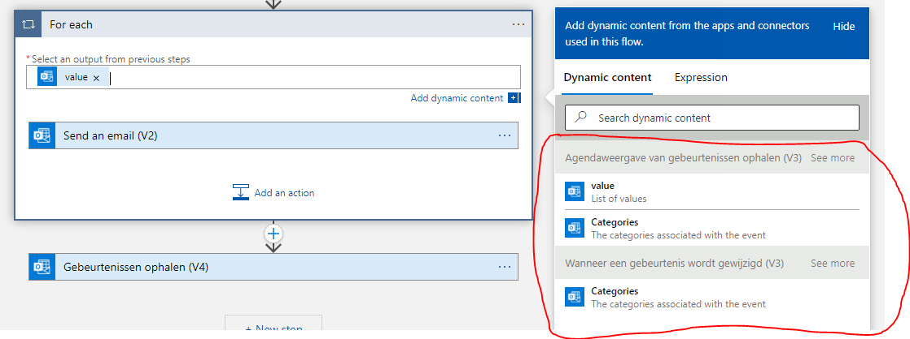

So in the red area you can see your previous steps and the values that u can use from those steps now the SEE MORE option is very important here even tough it is kind of faded into the background.

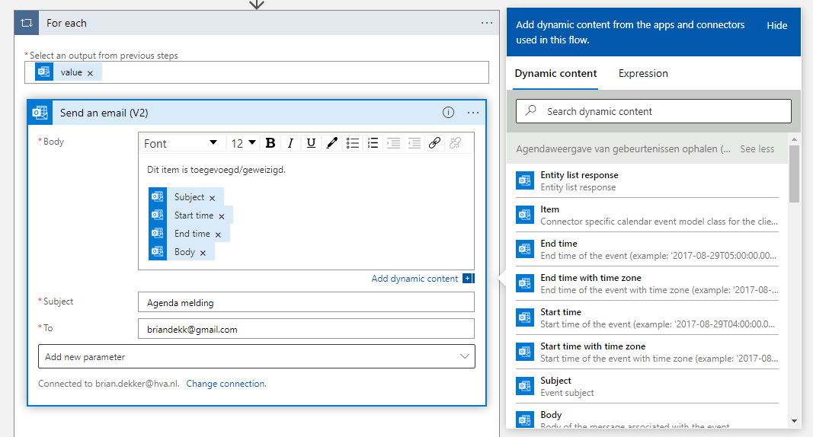

As you can see now I use several different variables that I extract from the output if the previous step in the body of my notification email whenever an event is created or changed.

Whenever I add or change an event this is the email I now get:

